Children’s Menu $8.00 (Ages 12 and under please)
Substitute Sweet Potato Fries $1.50
Cheeseburger with French Fries
Grilled Cheese with French Fries
Fried Chicken Tenders with French Fries
Penne Pasta tossed with Queso
Kid’s Fountain Drinks (Coke, Diet Coke, Sprite, Fanta Orange, Dr. Pepper, or Lemonade) $1.25
Juice (Apple, Orange or Cranberry) $2.25

Chisos | Texas | Salsa
Western | Grill | Queso
Pepper | Nueces | Cowboy

P | A | B | D | W | Q | T | J | H | C
E | Z | W | E | S | T | E | R | N | H
P | U | X | T | T | E | X | A | S | I
P | A | R | E | P | A | B | N | X | S
E | N | G | R | I | L | L | U | W | O
R | M | Q | A | B | W | U | E | Z | S
B | S | A | L | S | A | R | C | G | M
Q | U | E | S | O | N | E | E | M | A
T | T | I | D | E | Q | M | S | B | Y
W | S | S | T | C | O | W | B | O | Y
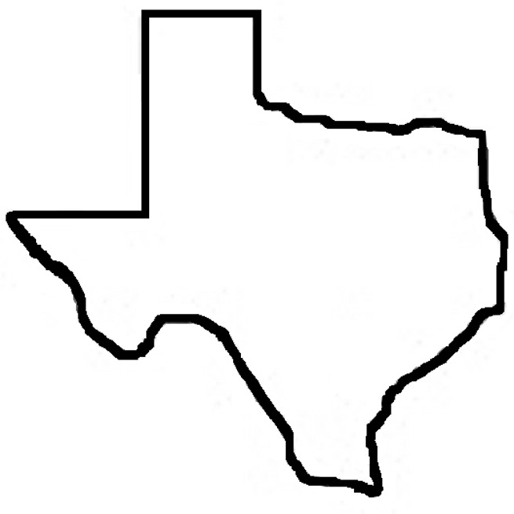
Word Search

